Name - Soumya Mehar
PRN – 24070521200
Section – C2

Practical 1
Task 1
Question 1: Insert Data into a Table
You have a table books with the following structure:
Column Name Data Type
Book_ID NUMBER
Title VARCHAR2(100)
Author VARCHAR2(100)
Price NUMBER
Insert the following rows into the books table:
Book_ID Title Author Price
1 The Great Gatsby F. Scott 300
2 To Kill a Mockingbird Harper Lee 350

Question 2: Insert Multiple Rows Using SELECT
Create a new table employees_backup with the same structure as the employees table. Insert
all data from the employees table into employees_backup using the SELECT statement.



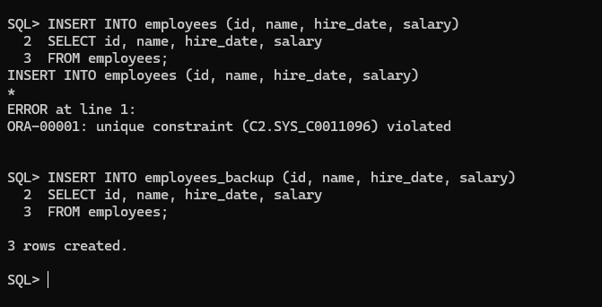

Question 3: Update Existing Data
Given a table students with the following columns:
Column Name Data Type
Student_ID NUMBER
Name VARCHAR2(100)
Grade NUMBER
Update the grade of the student with Student_ID = 101 to 90.

